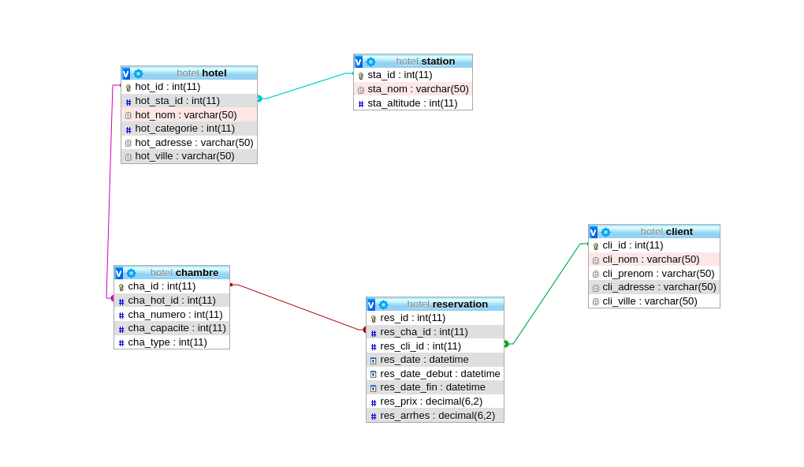

DROP DATABASE IF EXISTS hotel;

CREATE DATABASE hotel;
USE hotel;

CREATE TABLE station (
sta_id INT NOT NULL AUTO_INCREMENT PRIMARY KEY,
sta_nom VARCHAR(50) NOT NULL,
sta_altitude INT
);

CREATE TABLE hotel (
hot_id INT AUTO_INCREMENT NOT NULL,
hot_sta_id INT NOT NULL,
hot_nom VARCHAR(50) NOT NULL,
hot_categorie INT NOT NULL,
hot_adresse VARCHAR(50) NOT NULL,
hot_ville VARCHAR(50) NOT NULL,
FOREIGN KEY (hot_sta_id) REFERENCES station(sta_id),
PRIMARY KEY (hot_id)
);

CREATE TABLE chambre (
cha_id INT NOT NULL AUTO_INCREMENT ,
cha_hot_id INT NOT NULL,
cha_numero INT NOT NULL,
cha_capacite INT NOT NULL,
cha_type INT NOT NULL,
FOREIGN KEY (cha_hot_id) REFERENCES hotel(hot_id),
PRIMARY KEY (cha_id)
);

CREATE TABLE client (
cli_id INT NOT NULL AUTO_INCREMENT ,
cli_nom VARCHAR(50),
cli_prenom VARCHAR(50),
cli_adresse VARCHAR(50),
cli_ville VARCHAR(50),
PRIMARY KEY (cli_id)
);

CREATE TABLE reservation (
res_id INT NOT NULL AUTO_INCREMENT,
res_cha_id INT NOT NULL ,
res_cli_id INT NOT NULL ,
res_date DATETIME NOT NULL,
res_date_debut DATETIME NOT NULL,
res_date_fin DATETIME NOT NULL,
res_prix DECIMAL(6,2) NOT NULL,
res_arrhes DECIMAL(6,2),
FOREIGN KEY (res_cha_id) REFERENCES chambre(cha_id),
FOREIGN KEY (res_cli_id) REFERENCES client(cli_id),
PRIMARY KEY (res_id)
);

